Copyright Transfer Form

Title of the paper: Finansal Duygu Analizinde Model Genellemesi: FinBERT ve İnce Ayarlı Transformer Modellerinin Karşılaştırmalı İncelenmesi
The authors hereby transfer all copyrights in and to the manuscript named above in all forms and media, now or hereafter known, to the All Sciences Proceedings (AS Proceedings) effective if and when the paper is accepted for publication. The authors reserve all proprietary right
other than copyright, such as patent rights.

Everyone who is listed as an author in this article should have made a substantial, direct, intellectual contribution to the work and should take public responsibility for it.

This paper contains works that have not previously published or not under consideration for publication in other journals.

Authors:

Name | Signature | Date
Serkan KAYMAK | 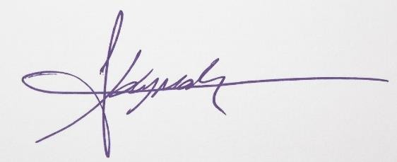 | 15.09.2026
Mansur Alp TOÇOĞLU | 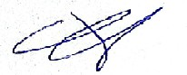 | 15.09.2026

